**Test 3 - Chapter 10**

Top of Form

Question**1**

Marks: 1

Determine if it is prefix code.

|  |  |  |
| --- | --- | --- |
| a → 000, b → 001, c → 010, d → 011, e → 100 |  |  |
| a → 0, b → 1, c → 00, d → 01, e → 10 |  |  |
| a → 0, b → 10, c → 110, d → 1110, e → 11110 |  |  |
| a → 00, b → 01, c → 10, d → 11, e → 110 |  |  |

Question**2**

Marks: 1

How many leaves are there in a decision tree representing the sorting of a list of 4 elements?

Answer:



Question**3**

Marks: 1

Find the value of the prefix expression

+ - \* 4 3 5 2.

Answer:



Question**4**

Marks: 1

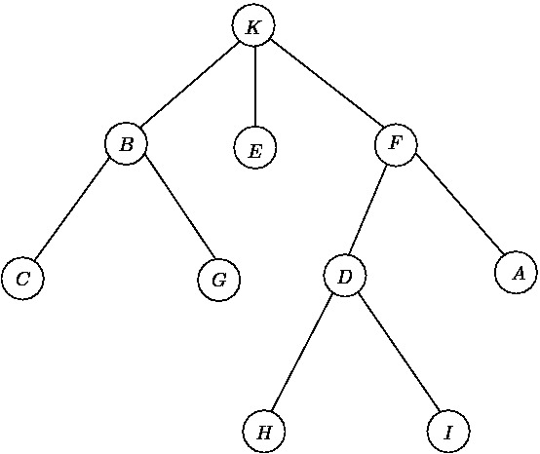  
  
What is the position of the letter D when using in-order traversal?

Answer:



Question**5**

Marks: 1

Find the value of the postfix expression

1 2 + 4 ↑ 3 9 – 5 8 – \* –

Answer:



Question**6**

Marks: 1

Determine a Huffman coding for the characters

A: 0.45, B: 0.25, C: 0.2, D: 0.1

Choose one answer.

|  |  |  |
| --- | --- | --- |
|  | a. A := 0 B:= 11 C:= 110 D:= 111 |  |
|  | b. A := 0 B:= 11 C:= 100 D:= 101 |  |
|  | c. A := 0 B:= 11 C:= 01 D:= 00 |  |
|  | d. A := 0 B:= 1 C:= 10 D:= 11 |  |

Question**7**

Marks: 1

Which graph is a forest but not a tree?

Choose one answer.

|  |  |  |
| --- | --- | --- |
|  | a. E:\FU\Course 3\D Math 2\MAD\test3\MAD121-Exam  Test 3 - Chapter 10_files\ST3-C03-3.gif |  |
|  | b. E:\FU\Course 3\D Math 2\MAD\test3\MAD121-Exam  Test 3 - Chapter 10_files\ST3-C03-1.gif |  |
|  | c. E:\FU\Course 3\D Math 2\MAD\test3\MAD121-Exam  Test 3 - Chapter 10_files\ST3-C03-4.gif |  |
|  | d. E:\FU\Course 3\D Math 2\MAD\test3\MAD121-Exam  Test 3 - Chapter 10_files\ST3-C03-2.gif |  |

Question**8**

Marks: 1

Find the least number of leaves in a balanced full 4-ary tree of height 3.

Answer:



Question**9**

Marks: 1

How many vertices are there in a full binary tree with 10 internal vertices?

Answer:



Question**10**

Marks: 1

Draw a binary search tree for the sentence  
  
"cong cha nhu nui thai son".   
  
Then find the number of comparisons needed to locate the word "nui".

Answer:



 

Bottom of Form

|  |  |  |
| --- | --- | --- |
| |  | | --- | | **Time Remaining** | | Top of Form    Bottom of Form | |